WEEK 7
Aim:
To develop a Student Course Management System using Node.js and Express.js that manages student information through HTTP requests, Express routes, URL parameters, query parameters, and JSON file operations.
Description:
This experiment demonstrates the development of a basic server-side web application using Node.js and Express.js. The application allows users to retrieve and search student information using different HTTP GET requests and Express routes. Node.js concepts such as NPM, global objects, built-in modules, and file-system operations are used along with Express.js concepts such as environment setup, routing, HTTP methods, URL parameters, and query parameters. Student data is stored in a JSON file and accessed using Node.js file-system operations.
Program:

Student Course Management System Using Node.js and Express.js

Program Code :
const express=require("express"); const app=express(); const fs=require("fs"); const PORT=3000;
const path=require('path'); app.get('/students',(req,res)=>{ let studentFilePath=path.join(__dirname,"students.json");

fs.readFile(studentFilePath,"utf8",(err,data)=>{ if(err){
console.log(err); return;
}

let students=JSON.parse(data);

res.send(students);
});

});

app.get('/students/:id',(req,res)=>{

let studentFilePath=path.join(__dirname,"students.json");

fs.readFile(studentFilePath,"utf8",(err,data)=>{ if(err){ console.log(err); return;
}

let id=req.params.id; let students=JSON.parse(data); let student=""; for(let i=0;i<students.length;i++){ if(students[i].id==id){ student=students[i]; break; }
}

if(!student){
res.send("No student exists with ID :",id);
} else{
res.send(`Student name : ${student.name} , Student course = ${student.course}`);
}
}); }); app.get('/search',(req,res)=>{

let studentFilePath=path.join(__dirname,"students.json");

fs.readFile(studentFilePath,"utf8",(err,data)=>{ if(err){ console.log(err); return;
}

let course=req.query.course;

let students=JSON.parse(data); let result=[];

for(let i=0;i<students.length;i++){ if(students[i].course.toLowerCase()==course.toLowerCase()){ result.push(students[i]);
}
} if(result.length==0){ res.send("No students are enrolled in the Course : ",course);
} else{ res.send(result);
}

});
}); app.get("/system",(req,res)=>{ const os=require('os'); let version=os.version(); let platform=os.platform(); let arc=os.arch(); res.send(`Platform : ${platform} , Version : ${version} , Architecture : ${arc}`);

}); app.get("/dns",(req,res)=>{ const dns=require("dns"); dns.lookup("google.com",(err,address)=>{
if(err){ res.send(err); return ; } res.send(`Domain : google.com , IP Address : ${address}`);

});

});
app.listen(PORT,()=>{ console.log("Server is listening on port ",PORT);
});

Data : Students.json
[
{
"id": 101,
"name": "Lasya",
"course": "Node.js"
},
{
"id": 102,
"name": " Rahul",
"course": "Java" },
{
"id": 103,
"name": "Ani",
"course": "MongoDB"
}
]

Execution Of the program
Method | URL/Route Purpose
GET | http://localhost:3000/student  Retrieves all student records  s
GET | http://localhost:3000/student  Retrieves a student using their ID  s/:id
GET | http://localhost:3000/search?  Searches students based on course  course=Node.js
GET | http://localhost:3000/system Displays system/OS information
GET | Performs DNS lookup and displays  http://localhost:3000/dns  IP information

Output: 1) Get all students: localhost:3000/students
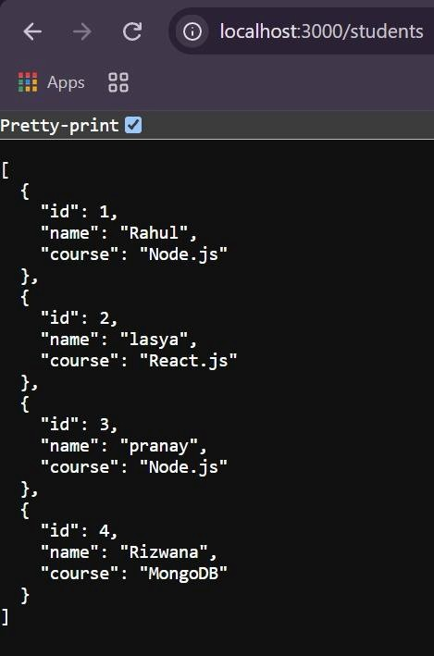

2) Get student with id =2 : localhost:3000/students/2
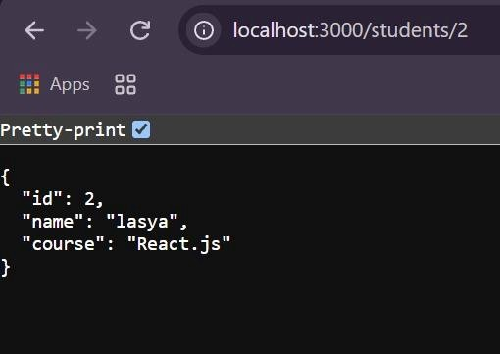

3) Get students with course Node.js: localhost:3000/search?course=Node.js
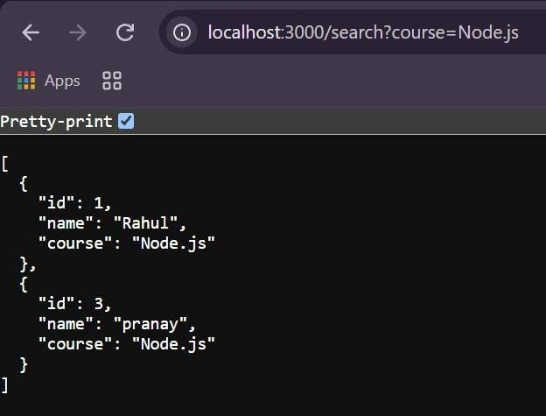

4) Get system information : localhost:3000/system
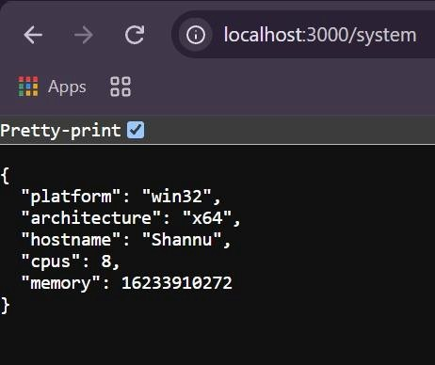

5) Get dns information : localhost:3000/dns
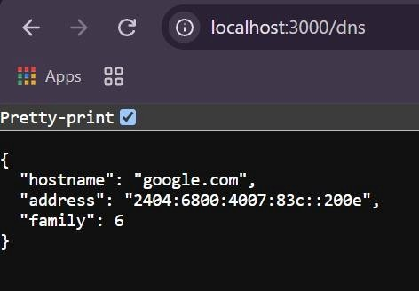

Result:
The Student Course Management System was successfully developed using Node.js and Express.js. The application demonstrates routing, HTTP GET methods, URL parameters, query parameters, built-in modules, file-system operations, and JSON-based student data management.

